|  |
| --- |
| US Department of Labor  office of labor-management standards |
| LM-21 Electronic Form |
| Functional Requirements |
| Release v1.0 |
|  |

**Revision History**

|  |  |  |  |
| --- | --- | --- | --- |
| **Date** | **Revision** | **Description** | **Author** |
|  | **1.0** | **Initial Draft** | **Bineeta Adityan** |
|  |  |  |  |
|  |  |  |  |

**Contents**

1. Background 1

2. Project Description 1

3. Purpose 1

3.1. Definitions, Acronyms, Abbreviations 1

3.2. References 2

4. FUNCTIONAL REQUIREMENTS 2

4.1. Login 2

4.1.1. Business Requirements 3

4.1.2. Registration Requirements 3

4.2. Page Level Requirements 3

4.2.1. Page 1 3

4.2.1.1. Business Requirements 3

4.2.1.2. Functional Requirements 3

4.2.1.3. Header Section 3

4.2.1.4. Footer Section 4

4.2.1.5. Design 4

4.2.1.6. Requirements 4

4.2.1.7. Section/Field Level Requirements 4

4.2.2. Page 2 – STMT B 6

4.2.2.1. Business Requirements 6

4.2.2.2. Functional Requirements 6

4.2.2.3. Header Section 6

4.2.2.4. Footer Section 6

4.2.2.5. Design 7

4.2.2.6. Requirements 7

4.2.2.7. Section/Field Level Requirements 7

4.2.3. Page 3 – STMT C 10

4.2.3.1. Business Requirements 10

4.2.3.2. Functional Requirements 10

4.2.3.3. Header Section 10

4.2.3.4. Footer Section 10

4.2.3.5. Design 10

4.2.3.6. Requirements 11

4.2.4. Page 4 – STMT D 12

4.2.4.1. Business Requirements 12

4.2.4.2. Functional Requirements 12

4.2.4.3. Header Section 12

4.2.4.4. Footer Section 13

4.2.4.5. Design 13

4.2.4.6. Requirements 13

4.2.5. Validation Summary Page 14

4.2.6. Other functionalities 14

# Background

The Labor-Management Reporting and Disclosure Act of 1959, as amended (LMRDA), requires public disclosure of agreements or arrangements made between any person, including labor relations consultants and other individuals and organizations, and an employer to undertake certain activities concerning employees or labor organizations. Pursuant to Section 203(b) of the LMRDA, every person who undertakes any such activity under an agreement or arrangement with an employer must file with the Secretary of Labor a detailed report of receipts and disbursements annually for each fiscal year during which payments were made as a result of any such agreement or arrangement. The Secretary, under the authority of the LMRDA, has prescribed the filing of the Receipts and Disbursements Report, Form LM-21, to satisfy this reporting requirement.

The information required to be reported in Form LM-21, as set forth in the form and instructions, includes (1) receipts of any kind received directly or indirectly from employers on account of labor relations advice or services, and (2) disbursements of any kind made directly or indirectly in connections with such services for each fiscal year during which payments were made or received as a result of an agreement or arrangement to undertake activities of the type described in LMRDA Section 203(b).

Currently, Office of Labor-Management Standards’ (OLMS) offers a facsimile of the LM-21 that can be downloaded from the website. Filers must manually complete and sign the LM-20 before mailing a copy to OLMS. Once OLMS receives the document, a DRDA staff member registers receipt of the document in the OLMS Report Tracking System (ORTS) system before the document is shipped to a third-party vendor to be scanned. After scanning the document, the scan vendor returns the scanned image to OLMS, and using ORTS system, the scanned image is uploaded into the e.LORS database. Once an image has been successfully loaded into the e.LORS database, the document is disclosed via OLMS’ Online Public Disclosure Room.

# Project Description

The Electronic Forms System (EFS) is the Office of Labor-Management Standards’ (OLMS) web-based system for completing and submitting labor organization and other reports. Currently, the EFS system is available for submitting LM-2, LM-3, LM-4 and LM-30 filers. The goal for the management is to make the system available to all other annual reports to help reduce the number of paper submissions.

# Purpose

The purpose of this project is to create the electronic version of the LM-21 report. Electronic LM-21s will be available via the EFS system.

# Definitions, Acronyms, Abbreviations

The following is a list of commonly used acronyms used throughout this document:

| Term | Definition |
| --- | --- |
| DOL | Department of Labor |
| e.LORS (5.14) | Electronic Labor Organizations and Reports System |
| FRD | Functional Requirements Document |
| OLMS | Office of Labor Management and Standards |
| OMB | Office of Management and Budget |
| PO | Program Office |
| RD | Regional Director |
| SQL | Structured Query Language |
| EFS | Electronic Filing System |
| LM | Labor Management |
| ORTS | OLMS Report Tracking System |
| LMRDA | Labor-Management Reporting and Disclosure Act |
| Filer | Users who prepare and sign the form |
| Preparer | Users who prepare the form |
| HTML link | HyperText Markup Language link |
| DIS | Division of Interpretations and Standards |

# References

* LM-21 PDF form
* LM-21 Instructions document

# FUNCTIONAL REQUIREMENTS

* The preparer or filer shall register his/her user account in EFS system to prepare and submit the LM-20 and LM-21 forms.
* Upon successful login, the filer or preparer shall be able to start a new form or access all in-progress forms.
* The system will have the field level and form level validation rules to authenticate the data before the submission

# Login

The EFS system will have a link to navigate to the LM-21 user interface. The filer or preparer may create a new account or may use an already existing account to access the form.

# Business Requirements

Every person required to file a Form LM-20 also must file an annual Form LM-21 Receipts and Disbursements Report, if any payments were made or received during the fiscal year as a result of arrangements of the kind requiring Form LM-20. To submit an LM-20 and LM-21, the filer is required to register the Organization which the filer is associated. Upon completing the registration of the organization, the system will assign a **File Number** and an **Access Key** to the filer. The filer should be able to use the same access Key to open LM-20 and LM-21 forms.

# Registration Requirements

A filer or a preparer of the special reports who has not registered in EFS shall be able to register themselves using the EFS user registration module.

Filers or preparers of a special report shall be able to register themselves in the EFS system using the ***EFS User Registration module*** and choose a user id and password which can be used later to access the LM-20 and LM-21 reports. For the detail requirements, refer the Filer-Registration Requirements section in the LM-20 Electronic requirements document.

# Page Level Requirements

Page level requirements and the validation rules for each page are detailed throughout this document.

# Page 1

# Business Requirements

Page 1 captures the information about the reporting individual/organization. After beginning a new LM-21 form successfully, the EFS system will prefill the information provided by the filer during the registration in section #1 and section #3 of the LM-21. The system will allow the filer to modify all of this information except the File Number and the Organization name. The information for section 1 and section #3 are as follows:

* File number assigned to the filer.
* Full name of the filer.
* Name of the Organization provided by the filer during the registration.
* Address provided by the filer during the registration.

# Functional Requirements

System shall display ‘Page 1’ in the following states.

* When the filer successfully logs in to an LM-21 form.
* When the filer selects the “<” (PREVIOUS)’ button on Page 2, ‘STMT B’.
* When the filer selects the ‘MAIN’ link from Left Navigation Panel

# Header Section

The header and footer items pictured below will be displayed on Page 1.

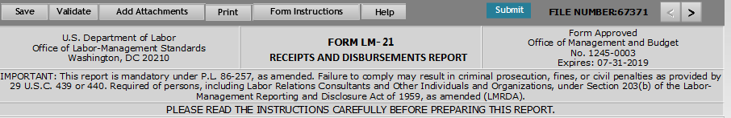

# Footer Section

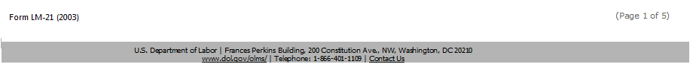

# Design

A mock-up design for Page #1 is displayed below.

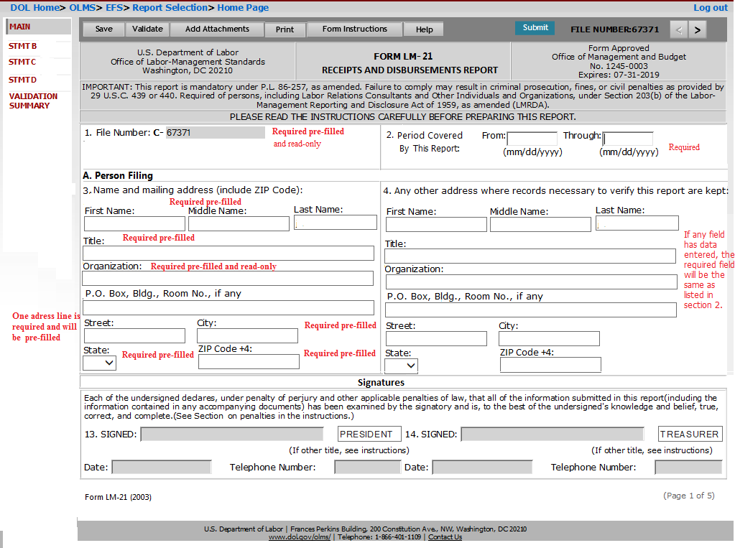

# Requirements

Page #1 is the landing page after a user successfully logs in and choses either to create a new LM-21 or work on an existing LM-21. The system will pre-populate some of the fields upon loading the page. Items 1-4 along with the signature section will be listed in this page.

# Section/Field Level Requirements

* **1 –File number. C** - The system shall pre-fill the file number assigned to the consultant selected by the user when the form is started. This field will be read-only.
* **2. Period Covered By This Report:** - The following two date fields will be listed in this section.
  + **From:** - This will be a beginning date of the fiscal year covered in the report. The format for the field should be MM/DD/YYYY.
  + **Through:** - This will be the ending date of the fiscal year covered in the report. The format for the field should be MM/DD/YYYY.
* **A. Person Filing** – This will be the section title for the sections 3 and 4.
  + **3.** **Name and mailing address (include ZIP Code)** – This section will be used to report the contact information for the person filing. Fields listed in this section and their requirements are described below:
* **First Name** – This will be a text field to enter the First Name of the reporting individual. The field will be pre-filled upon successful login. The filer will be able to modify the information.
* **Middle Name** - This will be a text field to enter the Middle Name of the reporting individual. The field will be pre-filled upon successful login. The filer will be able to modify the information.
* **Last Name** - This will be a text field to enter the Last Name of the reporting individual. The field will be pre-filled upon successful login. The filer will be able to modify the information.
* **Title** - This will be a text field to enter the job Title of the reporting individual. The field will be pre-filled upon successful login. The filer will be able to modify the information.
* **Organization** - This will be a text field to enter the Organization. The field will be pre-filled upon successful login and will be in read-only. Users needing to change an organization name must contact DRDA.
* **P.O. Box, Bldg., Room No., if any** - This will be a text field to enter the P.O Box or Building/room number. The field will be pre-filled upon successful login. The filer will be able to modify the information.
* **Street** - This will be a text field to enter the street address which the maul should be directed. The field will be Pre-filled upon successful login. The filer will be able to modify the information.
* **City**- This will be a text field to enter the name of the City. The field will be Pre-filled upon successful login. The filer will be able to modify the information.
* **State** - This will be a drop-down field to enter the State. The field will be Pre-filled upon successful login. The filer will be able to modify the information. The drop down must list of all states code plus '00' for a non-state.
* **Zip Code** **+4** – This will be a text field in 5 +4 format (xxxxx-xxxx). The field will be Pre-filled upon successful login. The filer will be able to modify the information.
  + **4. Any other address where records necessary to verify this report are kept:** – This section/field will be used to report any other address to be kept in the record.

Fields listed in this section and its requirements are described below:

* **First Name** – This will be a text field to enter the First Name of the individual.
* **Middle Name** - This will be a text field to enter the Middle Name of the individual.
* **Last Name** - This will be a text field to enter the Last Name of the individual.
* **Title** - This will be a text field to enter the job Title of the individual
* **Organization** - This will be a text field to enter the Organization. The field will be pre-filled upon successful login and will be in read-only.
* **P.O. Box, Bldg., Room No., if any** - This will be a text field to enter the P.O Box or Building/room number.
* **Street** - This will be a text field to enter the street address which the mail should be directed.
* **City**- This will be a text field to enter the name of the City.
* **State** - This will be a drop-down field to enter the State. The drop down must list of all states code plus '00' for a non-state.
* **Zip Code +4** – This will be a numeric field in 5 +4 format (xxxxx-xxxx).

# Page 2 – STMT B

# Business Requirements

Page 2 captures separate statement of receipts for each employer from whom payments were received. The EFS system will not prefill any information in this page. The filer will enter the information about each employer from whom receipts were received directly or indirectly on account of labor relations advice, the date which the agreement/arrangement was terminated and the total amount of the receipts from the employer. If the filer select the ***Save and Calculate*** button, the EFS system will calculate the total amount entered for each employer and will populate the calculated amount in the “TOTAL RECEIPTS FROM ALL EMPLOYERS” field.

# Functional Requirements

System shall display ‘Page 2’ in the following scenarios.

* When the filer selects “>” (next)’ button on the ‘MAIN’ page.
* When the filer selects ‘STMT B link from the Left Navigation Panel.
* When the filer selects “<” (previous) button on the page ‘STMT C’

# Header Section

The header section pictured below will be displayed on Page 2.



# Footer Section

The footer section pictured below will be displayed on Page 2.

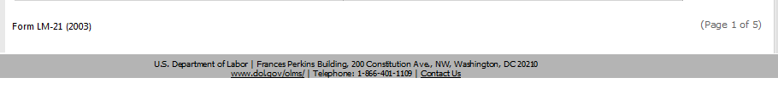

# Design

A mock-up design for Page #2 is displayed below.

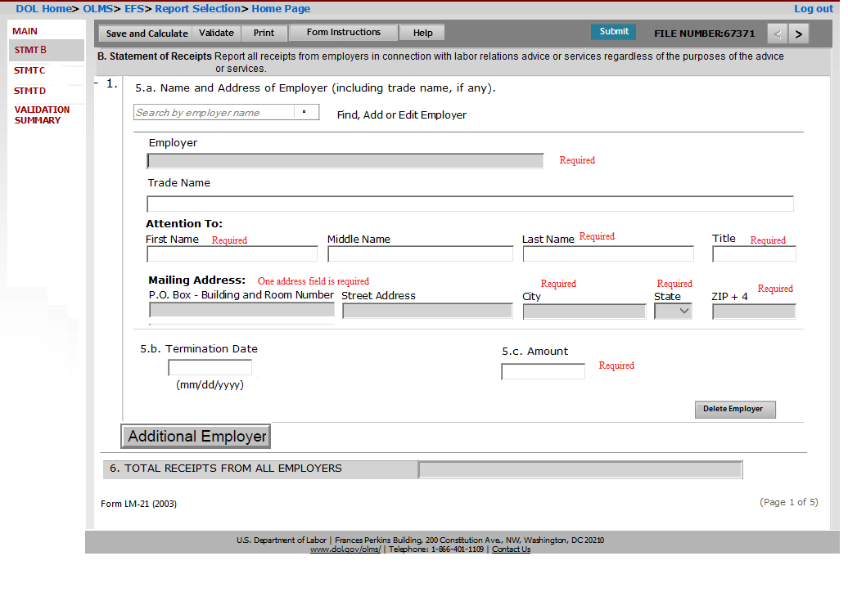

# Requirements

In this page the filer will report the Statement of Receipts. The page will list the title **“B. Statement of Receipts** Report all receipts from employers in connection with labor relations advice or services regardless of the purposes of the advice”. Items 5.a, 5.b, 5.c and 6 will be listed in this page.

# Section/Field Level Requirements

* **5. a. Name and Address of Employer (including trade name, if any): -** This section will be used to enter the details of the Employers with whom from whom receipts were received.
  + This section will have a search feature to lookup existing employers. The requirements for the search feature is listed below:
    - The system will provide a search option that allows filers to locate the employer by employer’s name in the section.
    - The filer needs to enter full or partial employer’s name in the search field
    - The system will return all matching employers in the system along with the address in a pop-up window (mock-up below).

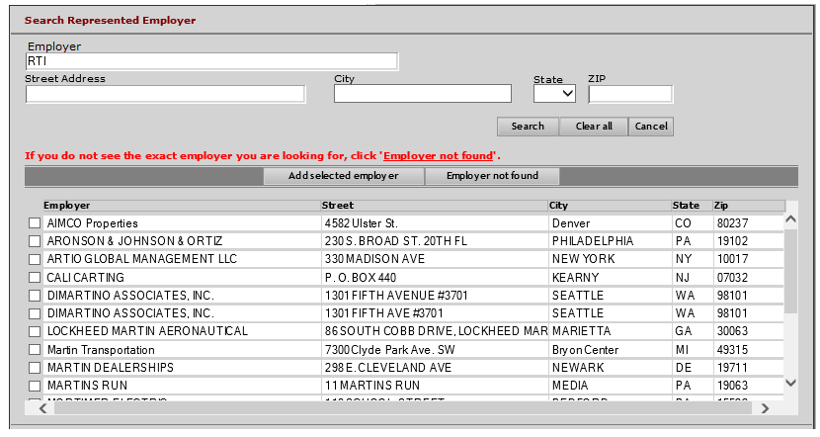

* + - The filer should be able to refine the search criteria using the “***Employer name***, ***Street Address***, ***City***, ***State*** and ***Zip***” in this page to find the employer record.
    - If the employer is selected from the search mechanism, the system will populate the ***Employer Name*** and all the address fields- ***P.O. Box – Building*** ***and Room Number, Street Address, City, State and Zip*** in Page 2.
    - If unable to find the employer information, the system will provide a functionality (‘Employer not found’ button) to return back to page 2.
    - If the user cannot find the employer data, the filer will return back to page 2 by clicking the link ‘**Employer not found**’ and will enter the details of the employer information.

Fields listed in this section and its requirements are described below:

* **Employer** – This will be the field to display the name of the Employer. Additional requirements for this field is listed below:
  + By default the field will be listed as read-only.
  + The filer will use the search field to locate the employer. If the employer is identified and selected using the search feature, the system will populate the selected employer’s name in this field.
  + If the filer is using ‘**Employer not found’** link in the ***Search*** window to return back to ***Page 2***, this field will be enabled for entering the employer’s name.
* **Trade Name, if any** – This will be a text field to enter the Trade or commercial name of the employer’s organization.
* **Attention To** - This section will list the name of the person to whom mail should be directed. The following fields will be listed.
  + **First Name** – This will be a text field to enter the First Name of the person to whom mail should be directed.
  + **Middle Name** - This will be a text field to enter the Middle Name of the person to whom mail should be directed.
  + **Last Name** - This will be a text field to enter the Last Name of the person to whom mail should be directed.
  + **Title** - This will be a text field to enter the job Title of the individual.

The following address fields are part of the Search and populate feature.

* **P.O. Box, Bldg., Room No., if any** - This will be a text field to enter the P.O Box or Building/room number.
* **Street** - This will be a text field to display the street address of the employer.
* **City**- This will be a text field to enter the name of the City.
* **State** - This will be a drop-down field to enter the State. The drop down must list of all states code plus '00' for a non-state.
* **Zip Code** **+4** – This will be a text field in 5 +4 format (xxxxx-xxxx).
  + The following requirements are applicable to all the address fields listed above.
    - By default all the fields listed above will be read-only.
    - The filer will use the search field to locate the employer. If the employer is identified and selected using the search feature, the system will populate all these fields.
    - If the employer is not found using the search feature and if the filer is using ‘Employer not found’ link in the ***Search*** page to return back to ***Page 2***, these fields will be enabled to enter the data.
* **5. b. Termination Date: -** This will be a date field to enter the date which the agreement was terminated. The field can be blank if the agreement is not terminated. The field will be in “MM/DD/YYYY” format.
* **5. c. Amount** – This will be a numeric field to enter the total amount of the receipts from the selected employer.
* **6**. **TOTAL RECEIPTS FROM ALL** **EMPLOYERS** – This will be a calculated field. When the filer select “**Save and Calculate**” button the system will aggregate the amounts listed for each employers (5.c) and populate the calculated value in this field.

This page has additional features included. The features and its requirements are listed below:

* + **Additional Employer**: Clicking this button will add a new section (items 5.a, 5.b and 5.c) to enter the details of another employer. The system will not limit the number of employers that can be added.
  + **Delete Employer**: This button will be listed under each new section created. Clicking this button will remove the selected section (items 5.a, 5.b and 5.c). But if there is only one section listed on the page, then the system will only clear the data entered in that section.

# Page 3 – STMT C

# Business Requirements

Page 3 captures the itemization of all salaries, allowances, and other disbursements (including reimbursed expenses) to all officers and employees of the reporting organization in connection with labor relations advice or services. The EFS system will not prefill any information in this page. The filer will enter the details of the itemized disbursements to each officer/employee of the reporting organization. If the filer select the ***Save and Calculate*** button, the EFS system will sum the total itemized disbursements entered for each employer and will populate the calculated amount in the “14. Total Disbursements (Sum of Items 8-13)” field.

# Functional Requirements

System shall display page 3 ‘Item9&10’ in the following scenarios.

• When the filer selects “>” (next)’ button on page ‘STMT B’

• When the filer selects ‘STMT C’ link from Left Navigation Panel

• When the filer selects “<” (Previous)’ button on page ‘STMT D’

# Header Section

The header item pictured below will be displayed on Page 3.



# Footer Section

The footer item pictured below will be displayed on Page 3.



# Design

A mock-up design for page 3 is pictured below:

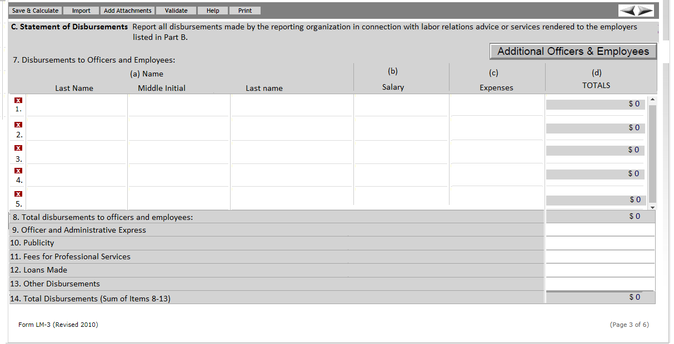

# Requirements

In this page the filer will report the itemized disbursements to each officers and employees. The page will list the title “**C. Statement of Disbursements** Report all disbursements made by the reporting organization in connection with labor relations advice or services rendered to the employers listed in Part B.”

Fields listed in this section and its requirements are described below:

* **7. Disbursements to Officers and Employees**: This section will list the Name, Salary, Expenses and the Total disbursements to each Officers/ Employees. The following fields will be listed in this section.
* **(a) Name –** Three separate fields will be listed to enter the First Name, Last Name and Middle Initial of the Officer/Employee.
  + **First name –** Text field to enter the First Name
  + **Middle Initial -**  Text field to enter the Middle Initial
  + **Last Name -** Text field to enter the Last Name
* **(b) Salary –** An integer (non-negative) field to enter the gross salary given to the selected Officer/Employee.
* **(c) Expenses –** An integer (non-negative) field to enter the expenses paid to the officer/employee.
* **(d) Totals –** This will be a system calculated field. Once the data is entered in b and c, and the filer select ***Save and Calculate*** button, the system will add the amount entered in b and c and will populate the field. By default the field will display $0.

**Note**: By default the system should list 5 rows of the data field in section 7. Each rows should have a delete (x) button, so that the filer should be able to clear the data entered.

* **8. Total disbursements to Officers and employees**: - This will be a system calculated field. When the filer select ***Save and Calculate*** button, the system will aggregate the amount populated in the **Totals** field (item (d) allocated to each officer/employee and will be populated in this field. By default the field will display $0.
* **9. Office and Administrative Expenses –** This will be a numeric (non-negative) field to enter disbursements made for all office and the administrative expenses in connection with labor relations advice and services.
* **10. Publicity -** This will be a numeric (non-negative) field to enter the total disbursements related to publicity in connection with labor relations advice or services.
* **11.** **Fess for Professional Services** - This will be a numeric (non-negative) field to enter the total fees paid for professional services provided by persons other than officers and employees of the reporting organization.
* **12.** **Loans Made** - This will be a numeric (non-negative) field to enter the total of all loans made by the reporting organization in connection with labor relations advice or service provided to an employer.
* **13.** **Other** **Disbursements** - This will be a numeric (non-negative) field to enter the total of all other disbursements made by the reporting organization in connection with labor relations advice or services provided to an employer.
* **14.** **Total Disbursements (sum of Items 8-13)** - This will be a system calculated field. When the filer select ***Save and Calculate*** button, the system will aggregate the amount populated in item 8-13.

This section has additional requirements as listed below:

* + **Additional Officers & Employees**: Clicking this button will add a new section 7 (items 7.a, 7.b, 7.c and 7.d) to enter the disbursements details of another Officer /Employee. The system will not limit the number of records that can be added.

# Page 4 – STMT D

# Business Requirements

Page 4 captures the disbursements for reportable activities to individuals other than the Officers/employees of the reporting organization. The EFS system will not prefill any information in this page. The filer will be able to add the details of each reportable activity separately in this page.

# Functional Requirements

System shall display page 4 ‘STMT D’ in the following scenarios.

• When the filer selects “>” (next)’ button on page ‘STMT C’.

• When the filer selects ‘STMT D’ link from Left Navigation Panel.

• When the filer selects “<” (Previous)’ button on page ‘Validation Summary’ page.

# Header Section

The header item pictured below will be displayed on Page 4.



# Footer Section

The footer item pictured below will be displayed on Page 4. 

# Design

A mock-up design for page 4 is listed below:

 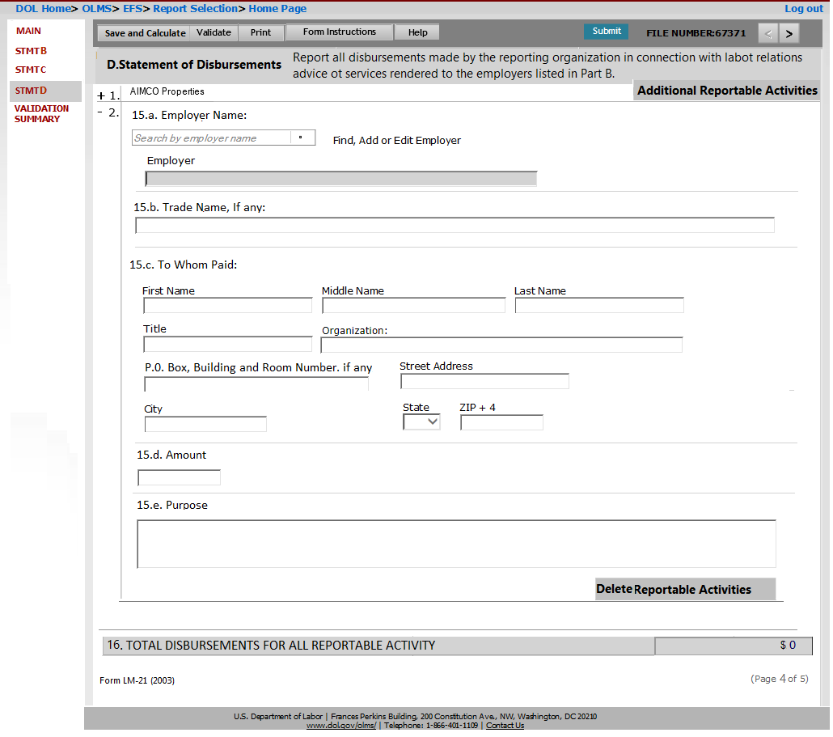

# Requirements

The filer should be able to add the details of the disbursements for each reportable activity. The page will list sections 15a, 15.b, 15.c, 15.d, 15.e and 16.

Fields listed in this section and their requirements are described below:

* **15. a. Employer Name** - This will be a text field to enter the name of the employer for whom you made the disbursement.
* **15. b Trade Name, If any: - Trade Name, if any** – This will be a text field to enter the employer’s trade or commercial name.
* **15.c. To Whom payment was made: -** This section will list the following fields to enter the details of the person whom the disbursement was made.
* **First Name** – This will be a text field to enter the First Name of the person to whom payment was made.
* **Middle Name** - This will be a text field to enter the Middle Name of the person to whom payment was made.
* **Last Name** - This will be a text field to enter the Last Name of the person to whom payment was made.
* **Title** - This will be a text field to enter the job Title of the individual.
* **Organization** – This will be a text field to enter the Organization name of the employer.
* **P.O. Box, Bldg., Room No., if any** - This will be a text field to enter the P.O Box or Building/room number.
* **Street** - This will be a text field to enter the street address of the person whom the payment was made
* **City**- This will be a text field to enter the name of the City.
* **State** - This will be a drop-down field to enter the State. The drop down must list of all states code plus '00' for a non-state.
  + **Zip Code** **+4** – This will be a text field in 5 +4 format (xxxxx-xxxx).
* **15. d. Amount -** This will be an integer field (non-negative) to enter the dollar amount of the disbursement.
* **15. e. Purpose -** This will be a text field to enter the purpose of the disbursement in detail.
* **16. TOTAL DISBURSEMENTS FOR ALL REPORTABLE ACTIVITY -** This will be a system calculated field. The system will aggregate the amount listed in item 15.d for each reportable activity listed. The field will be populated when the filer select ***Save and Calculate*** button.

This section has additional requirements as listed below:

* + **Additional Reportable Activities**: Clicking this button will add a new section listing items 15.a, 15.b, 15.c, 15.d and 15.e. to enter the disbursements details of another individual. The system will not limit the number of records that can be added.
  + **Delete Reportable Activity**: This button will be listed under each new section created. Clicking this button will remove the selected section (items 15.a, 15.b, 15.c, 15.d and 15.e.). But if there is only one section listed on the page, the system will only clear the data entered in that section.

# Validation Summary Page

* The Validation summary page shall list all errors, in the order of schedules in the LM-21 form.
* Each error shall have a Page number, Schedule number, Row number and error message.
* A hyper link shall be provided along with each error. When user selects this link system shall redirect user to the Schedule or Page that has an error.

# Other functionalities

The following functionalities are common to all the annual reports. LM-20 form will use the same architecture to perform these functionalities.

**Save** – This button will save the current page and the data will be inserted to the EFS temporary database.

**Validate** – This button will all the pages, except the Main page performs the following.

1. Saves the page data to the EFS temporary database
2. Trigger a page level validation and returns any error to be corrected.

**Submit** – This button will selected as the final step to submit the LM-20 form. The form can be submitted only after the filer signed the form. Once the filer signed the form and clicked on Submit button, the data will be moved from the temporary database to the eLORS database.

**Form Instructions** – This button will open the instructions page in a new tab. DIS will be responsible for providing the HTML version of the LM-20 instructions.

**EFS Help** – This button will open the EFS Help page in a new tab.